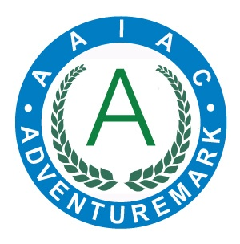
ADVENTUREMARK
www.adventuremark.co.uk
WHITEMOOR LAKES
Has met the necessary standards for the safe delivery of
adventure activities as defined by the
Adventure Activities Industry Advisory Committee.

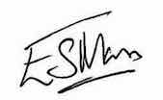
Elspeth Mason, Chair (AAIAC)

Abseiling | Kayaking
Archery | Leap of Faith
Artificial Climbing Wall | Low Ropes Courses
Assault Course | Orienteering
Bushcraft | Sailing
Canoeing | Stand Up Paddle Boarding
High Ropes Courses | Team Building
Improvised Rafting | Zip Wires

Date Issued : 25th July 2024 Expiry Date : 25th July 2026

Certificate No : AAA101339

